
Roserton Street, Isle of Dogs, London, E14 3PG
Tel: 020 7531 0310
Email: admin@island-house.org
HALL HIRER PACK

Contents:
- Viewing & Bookings
- Hall Hire Charges
- Charges Information & Additional Services
- Main Hall standard layout and dimensions
- Small Hall standard layout and dimensions
- Terms and Conditions
- Fire Procedures (Main Hall and Small Hall)
- Location Map and Contact Details

VIEWINGS & BOOKINGS

To view Island House’s facilities:
Please call the office to book an appointment, alternatively you can email us and a member of staff will gladly show you around the premises and answer any questions you may have. PLEASE NOTE: Please take care not to disturb any sessions taking place during your visit.

Office opening hours:
Monday – Friday 9.30am – 4.30pm

Main Hall Small Hall
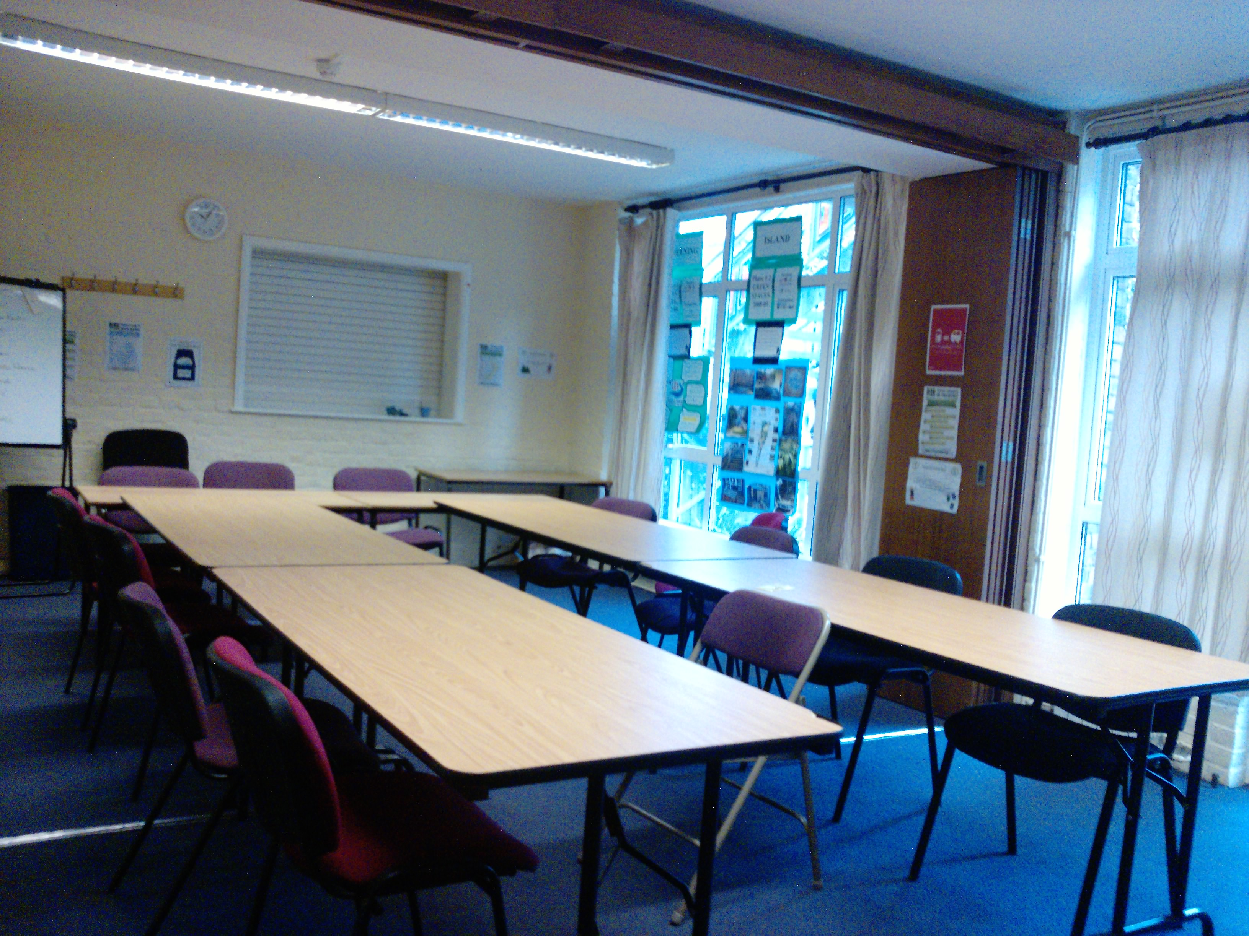

To make a BOOKING at Island House:
Please call, email or visit during office hours and our Reception team will be happy to provide any further information you may require, such as availability or additional services.

A £50 booking deposit (or half the total fee, whichever is least) is required to secure the booking. Payment must be made in cash at least one week prior to your booking. This amount will then be deducted from your final bill.

A further £100 cash deposit will also be required to cover any damages. This is fully refundable (providing no damages occurred) once the director receives the caretakers premises report the following week.

Provisional bookings without a deposit are normally held for up to 5 days maximum.

Hirers are responsible for washing and clearing the space they’ve used at the end of their function ready for the next group to meet.

A communal kitchen is available with both halls at no extra charge.

HALL HIRE CHARGES

Private/Public Event Hire:

 | Main Hall | Small Hall | Chapel
Hourly Rate (in office hours) | £35/hour | £25/hour | £15/hour
Hourly Rate (out of hours) | £50/hour | £35/hour | £25/hour

(Booking times must include setting up and tidying away)

Please note: In exceptional circumstances discretionary rates can be discussed with the Centre Director.

CHARGES INFORMATION & ADDITIONAL SERVICES

Facilities
Hiring any hall/room at Island House includes the use of:
- Tables & chairs appropriate to that room
- Kitchen facilities
- Toilets, cleaning equipment and products
- Use of our car park (if available)

Booking Deposit (non-refundable)
£50 or half the total booking fee, whichever is less, is required to secure your booking when initially booked. This is non-returnable. The remaining balance is normally due 14 days in advance of your hire date. No refund will be offered for cancellations made 5 working days (or less) prior to the function date. Cancellations before this date will be refunded, less the initial booking deposit.

Returnable (‘Damages’) Deposits
An additional ‘Returnable Deposit’ of £100 will be required, paid in cash, prior to the date of your function (usually taken when booking is placed). This deposit is held in our safe during your function and can be collected the following week after your event, once the Centre Director has received a positive report from the weekend on-duty caretaker. This deposit is fully returnable, but deductions will be made to cover any damages, breakages, over-run of function times, extra cleaning costs or any other breaches of the terms and conditions of hire.

ISLAND HOUSE – MAIN HALL LAYOUT

Key: Orange: Property of IH Playgroup (No Access to Hirers)
Blue: Property of Island House Community Centre (Access to Hirers)
Green: Fire Exits

PRIVATE – NO ACCESS

PRIVATE – NO ACCESS

Cupboard containing all Main Hall tables & chairs

FIRE EXIT
Windows overlooking
Castalia Square

FIRE EXIT

NO ACCESS to hirers
Entrance from stairwell

PLEASE NOTE: Light Switches for the Main Hall are located by the Entrance doors on your left.

APPROX DIMENSIONS:
PLEASE NOTE: Hirers are asked to not remove/tamper with the Playgroup’s art/work on the walls of the hall – However, you are welcome to cover it over with decorations
LENGTH: 10m 64cm
WIDTH: 10m 92cm
HEIGHT: 10m 92cm
ISLAND HOUSE – SMALL HALL LAYOUT

Key: Orange: No Access to Hirers
Blue: Property of Island House (Access to hirers)
Green: Fire Exit

Stackable
Chairs & Tables

No access to hirers

FIRE EXIT

Windows overlooking
Patio garden

Foldable/partition
Doors

FIRE EXIT
FIRE EXIT

No access to hirers

APPROX DIMENSIONS:
LENGTH: 7m 50cm
WIDTH: 5m 15cm
HEIGHT: 2m 62cm
TERMS & CONDITIONS OF HALL HIRE

Any private/public groups wishing to hire a hall at Island House Community Centre must read the terms and conditions of hall hire and sign the booking form as proof of acceptance prior to the function date.

PREMISES AND FACILITIES
- Hirers must be aware of and agree to abide by all Health & Safety and Fire Procedure notices attached and displayed around both halls and communal areas. NOTE: Smoking is forbidden within Island House premises.
- When in the premises, hirers are responsible for maintaining appropriate vigilance and security measures, including ensuring the building isn’t left unlocked or unattended at any time.
- Hire fees include use of tables/chairs and kitchen facilities as appropriate to the hall being hired, toilets and free use of our private car park.
- All staircases above the first floor area and all office spaces are strictly out of bounds.
- Only half of the garden (up to the steel gate) at Island House is accessible to private hirers and must be treated with respect at all times. Prior arrangement is needed if you wish to access the garden area.
- Access to the second half of the garden (Island House Playgroup’s playground) and the use of their belongings i.e. toys/climbing frame/equipment is STRICTLY FORBIDDEN AT ALL TIMES. Failure to adhere to this condition will result in the loss of your returnable deposit.
- Island House is NOT licensed for the sale of alcohol. If hirers choose to set up a paid bar then they must obtain an occasional licence from the relevant licensing authority (LB Tower Hamlets). This does not apply for private (free) bar where there is no charge for the alcohol.

DEPOSITS AND FEES
- To secure your booking, a non-returnable BOOKING DEPOSIT of £50 or half of the total cost, whichever is less, is required to secure your booking when initially booked. This is non-returnable. The remaining balance is normally due 14 days in advance of your hire date. No refund will be offered for cancellations made 5 working days (or less) prior to the function date. Cancellations before this date will be refunded, less the initial booking deposit.
- In addition, a RETURNABLE (DAMAGES) DEPOSIT of £100 (in cash) will be required to be left in our safe over the weekend or date of your event. This should be given to the Office Manager or Centre Director at the least 1 week before your event takes place. if holding your function over the weekend and can be collected the following week after the Centre Director has received the premises report from the on-duty caretaker. This acts as a guarantor for any damages, breakages, noise disturbance, failure to leave the Centre at the agreed time in the same condition you found it or any other breaches of terms and condition. Failure to pay the RETURNABLE DEPOSIT will result in a VOID booking and the caretaker will be un-authorised to grant you access until the fee is paid in full.

ACCESS TIMES AND NOISE
- For an ‘All Day’ booking, access is normally possible anytime from 9am onwards to 11pm (see noise conditions below) On some dates, the hall(s) may only be available after earlier regular groups have finished. You will be made aware of any prior/conflicting functions happening on the day of your event at the time of booking.
- The Office Manager/Centre Director will arrange for the duty caretaker to be present at those times to open and lock-up for you. PLEASE NOTE: The caretaker will only wait a maximum of 30 minutes past the arranged time. If the hirer does not arrive (or finish and leave) within that half-hour slot, the caretaker will leave the site and await a further call from the hirer. There is an extra call-out charge of £25 per visit which will be deducted from your returnable deposit. Throughout your setting up period and at the end of your event, hirers must not leave the premises unlocked or unattended at any time or you will be held liable for any damage that occurs – one member of your party must wait for the duty caretaker to arrive.
- For all bookings, all music MUST finish by 11pm at the very latest. The halls must be fully vacated by 11.30pm, including members of the party who have stayed to clean; otherwise extra charges will occur.
- Island House is located in a quiet residential conservation area. Hirers must remind their guests to vacated the premises in a quiet, respectful manner without causing a disturbance for local residents, especially so after 10pm. Any complaints we receive from neighbours regarding excess noise at any time during your event, and any music or other noise disturbances of any kind after 11pm will result in an additional charge (minimum £50 per reasonable complaint received) being taken from your returnable deposit or added to your fee.

CLEANING
- All areas used by hirers must be fully cleared, cleaned and left in the same condition they were found in. This includes the removal of decorations; restoring furniture and fittings to their original storage place (a plan of both halls is included in this pack). Cleaning equipment (brushes, mops, cleaning solutions etc) are provided, as are bin bags, which when full should be placed inside the large big provided outside the centre next to the car parking area. NB: Please remember to clear and clean the kitchen, garden, toilet areas and car park if used by your group – these areas are often overlooked, but you are reminded that this falls into the communal areas which must be left in the same condition you found them in, ready for the next user.
- Failure to clean the space to an acceptable standard (at least as clean and tidy as it was found) will result in the loss of your returnable deposit.

MISCELLANEOUS
- All damage and breakages must be fully paid for by the hirer.
- Island House cannot accept any responsibility or liability for any items of value brought into the centre by hirers or any items that are left in the building unattended or overnight.

We trust you will abide by these Terms and Conditions in good faith, appreciating that Island House Community Centre is a charity seeking to serve the local community. We ask you to show respect to the centre, its user groups and our neighbours at all times. We hope your event goes well and is very successful.

Please sign the Hall Booking Form to confirm your acceptance of the above terms.
FIRE SAFETY
At Island House Community Centre

Exits & Equipment You must make yourself aware of the location of all FIRE EXTINGISHERS.
Fire Monitor At least one person should be appointed to be a FIRE MONITOR and should be able to take charge of evacuating the building.
Hall Fire Exit Routes The MAIN HALL has the following Fire Exit routes:
- Via the Fire Exit door leading to the garden, then through the gate. (BREAK GLASS TUBE ON GATE TO GAIN ACCESS)
- Down the stairs, through the main front entrance leading to the square.
The SMALL HALL has the following Fire Exit routes:
- Via the Fire Exit door leading to the garden, then through the gate. (BREAK GLASS TUBE ON GATE TO GAIN ACCESS)
- Down the hallway, left towards the main reception area, and out the main entrance.

*IMPORTANT INFORMATION* NO FIRE EXIT VIA SECOND FLOOR –
DO NOT GO UPSTAIRS!

Assembly Point Castalia Square/near the shops

Wheelchair Access Fire Exit route 3 (see above) is suitable for wheelchair access. Fire Exit route 1 & 2 will require assistance for wheelchair users.

IN THE EVENT OF FIRE:
- Raise the alarm
- Call the Emergency services on 999
- Evacuate the building in an orderly manner via the appropriate Fire Exit routes
- Fire Monitors seek to ensure the building is evacuated, report the status to the emergency services on their arrival and take a roll call at the assembly point.
- Only tackle the fire using the extinguishers provided if you are not putting yourself at risk by doing so.

If you notice any fire exit routes blocked, extinguishers not in place or anything else which might compromise fire safety, or once the Emergency services have been called please contact the Centre Director immediately.
CONTACT DETAILS:
Contact the Centre Director or Office Manager at Island House between
Monday to Friday, 9.30am – 4.30pm on:

Telephone: 020 7531 0310
Email: admin@island-house.org
Website: www.island-house.org

